Lab 05

- Implement SQL Operators: Demonstrate the use of different types of
operators in SQL with examples, including Arithmetic Operators, Logical
Operators, Comparison Operators.

CREATE TABLE Product (
ProductID INT,
ProductName VARCHAR(50),
Price DECIMAL(10,2),
Quantity INT,
Discount DECIMAL(10,2)
);

INSERT INTO Product VALUES
(1, 'Laptop', 50000, 2, 5000),
(2, 'Mobile', 20000, 3, 2000),
(3, 'Keyboard', 1500, 5, 100),
(4, 'Mouse', 800, 4, 50);
SELECT * FROM Product;
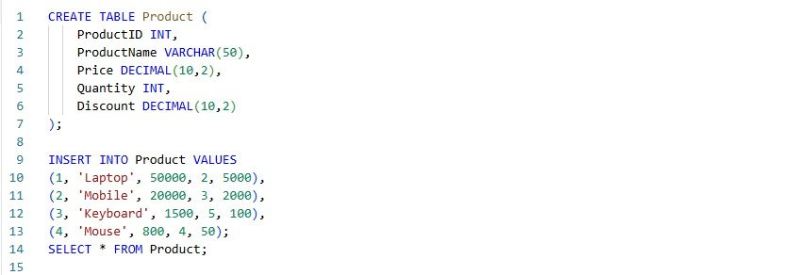
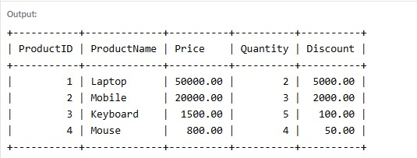

SELECT 'ARITHMETIC OPERATIONS' AS Operations;
SELECT ProductName, Price * Quantity AS TotalAmount
FROM Product;
SELECT ProductName, Price / Quantity AS DividedPrice
FROM Product;
SELECT ProductName, Quantity % 2 AS Remainder
FROM Product;

SELECT 'Comparison Operators' AS Operations;
SELECT * FROM Product
WHERE Price > 10000;
SELECT * FROM Product
WHERE Price < 10000;
SELECT * FROM Product
WHERE Price >= 20000;

SELECT 'Logical Operators' AS Operations;
SELECT * FROM Product
WHERE Price > 10000 AND Quantity >= 2;
SELECT * FROM Product
WHERE Price > 40000 OR Quantity >= 5;
SELECT * FROM Product
WHERE NOT Price > 10000;

